**Computer Organization 2018**

**HOMEWORK 3**

系級: 109資訊 學號: F74056247 姓名: 曾大瑋

**實驗結果圖(snapshot of result)**

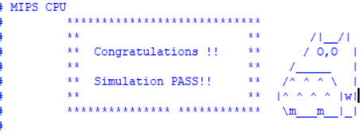

**波型圖(Waveform)**

**Please explain why your snapshot is correct**

(不用每條指令都解釋，挑一兩條指令解釋功能正確即可)

(You don’t need to explain all the instructions in the testbench. It is fine to pick one or two instructions in the testbench and explain the function is correct )

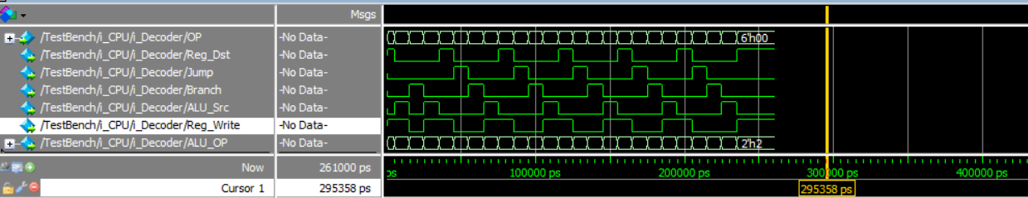

**Reason:**

可以看到在前面兩個指令後有五個相似的波形(為j跳回去的結果)

以及最後beq後結束

**心得(Report)**

beq和j常常會跳到莫名的地方,然後就不知道怎麼樣壞掉了

善用$display可以減少debug的時間和困難度